**DATABASE MANAGEMENT SYSTEM**

**PROJECT**

**Attendance Management System**

**BY :**

**Vivek Ramkumar**

**2018103082**

**Introduction:**

Attendance Management System is a software developed for daily student attendance in schools, colleges and institutes. If facilitates to access the attendance information of a particular student in a particular class. The information is sorted by the operators, which will be provided by the teacher for a particular class. This system will also help in evaluating attendance eligibility criteria of a student.

Attendance Management System basically has two main modules:

**¬ Admin login** can add/delete teachers,students,grade. Admin can create attendance charts and reports of the students.

¬ **Teacher login** can add daily attendance, generating report. Attendance report can be taken by given details of student details, date, class

**Purpose:**

The purpose of developing attendance management system is to computerized the tradition way of taking attendance which is done on hand written registers. It will be a tedious job to maintain the record for the user. The human effort is more here. The retrieval of the information is not as easy as the records are maintained in the hand written registers. Another purpose for developing this software is to generate the attendance report/chart of any student or a whole class between any given interval.

**SOFTWARE USED:**

**Operating system**: Windows 10

**Front-End Language:** HTML,CSS

**Back-End :** PHP,SQL

**DataBase Server:** MySQL

**DataBase Tools:** MySQL 8.0.19, MySQL Workbench 8.0 CE

**Tables:**















***ER DIAGRAM:***

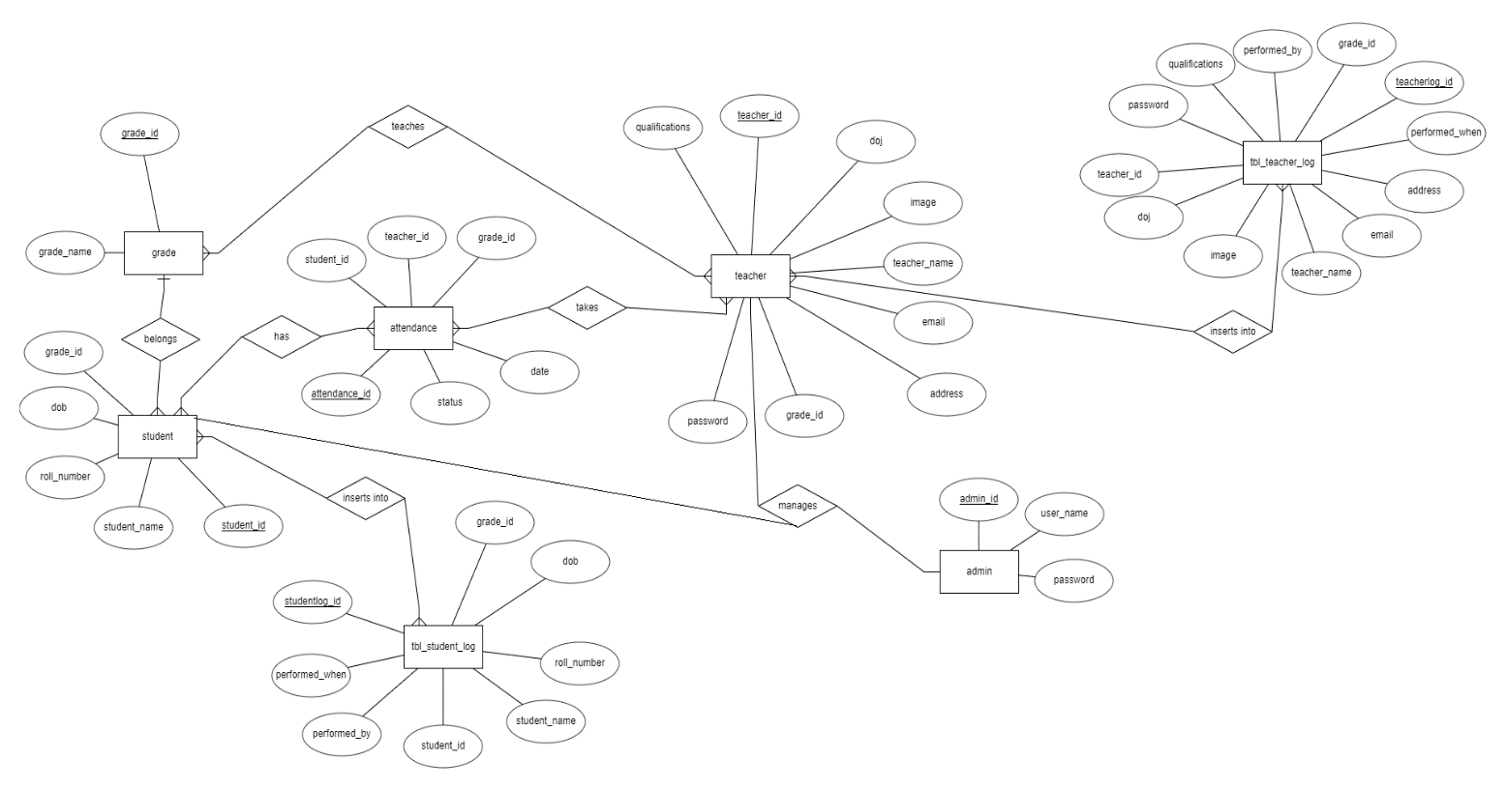

***RELATIONAL MODEL:***

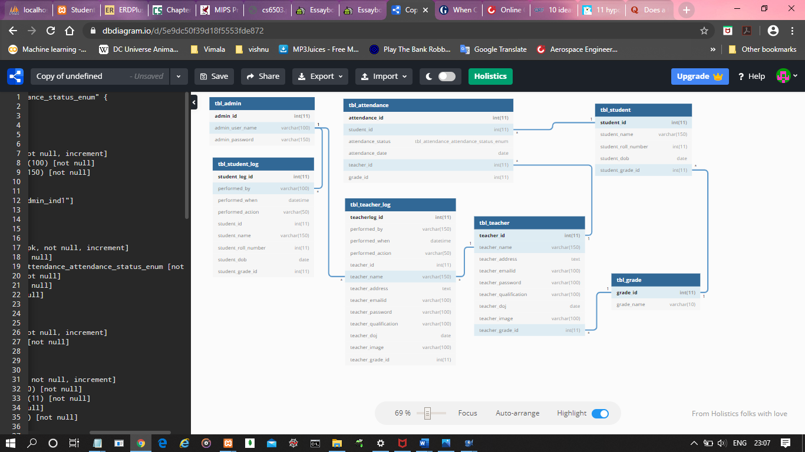

***TRIGGERS USED:***

**/*Trigger functions for `tbl_student_log` */**

**1. If tbl_student data is updated, trigger will insert into tbl_student_log**

DELIMITER $$

CREATE or replace DEFINER=CURRENT_USER TRIGGER student_log_update

before update

ON tbl_student

FOR EACH ROW

BEGIN

INSERT INTO tbl_student_log(performed_by,performed_when,performed_action,student_id,student_name,student_roll_number,student_dob,student_grade_id)

VALUES ('admin',now(),'UPDATE',new.student_id,new.student_name,new.student_roll_number,new.student_dob,new.student_grade_id);

END;

$$

1. **If tbl_student data is deleted, trigger will insert into tbl_student_log**

DELIMITER $$

CREATE or replace DEFINER=CURRENT_USER TRIGGER student_log_delete

before delete

ON tbl_student

FOR EACH ROW

BEGIN

INSERT INTO tbl_student_log (performed_by,performed_when,performed_action,student_id,student_name,student_roll_number,student_dob,student_grade_id)

VALUES ('admin',now(),'DELETE',old.student_id,old.student_name,old.student_roll_number,old.student_dob,old.student_grade_id);

END;

$$

1. **If tbl_student data is inserted, trigger will insert into tbl_student_log**

DELIMITER $$

CREATE or replace DEFINER=CURRENT_USER TRIGGER student_log_insert

after insert

ON tbl_student

FOR EACH ROW

BEGIN

INSERT INTO tbl_student_log (performed_by,performed_when,performed_action,student_id,student_name,student_roll_number,student_dob,

student_grade_id)

VALUES ('admin',now(),'INSERT',new.student_id,new.student_name,new.student_roll_number,new.student_dob,

new.student_grade_id);

END;

$$

**/*Trigger functions for `tbl_teacher_log` */**

1. **If tbl_teacher data is updated, trigger will insert into tbl_teacher_log**

DELIMITER $$

CREATE or replace DEFINER=CURRENT_USER TRIGGER teacher_log_update

before update

ON tbl_teacher

FOR EACH ROW

BEGIN

INSERT INTO tbl_teacher_log (performed_by,performed_when,performed_action,teacher_id,teacher_name,teacher_address,teacher_emailid,teacher_password,teacher_qualification,teacher_doj,teacher_image,teacher_grade_id)

VALUES (@username,now(),'UPDATE',new.teacher_id,new.teacher_name,new.teacher_address,new.teacher_emailid,new.teacher_password,new.teacher_qualification,new.teacher_doj,new.teacher_image,new.teacher_grade_id);

END;

$$

1. **If tbl_teacher data is inserted, trigger will insert into tbl_teacher_log**

DELIMITER $$

CREATE or replace DEFINER=CURRENT_USER TRIGGER teacher_log_insert

after insert

ON tbl_teacher

FOR EACH ROW

BEGIN

INSERT INTO tbl_teacher_log (performed_by,performed_when,performed_action,teacher_id,teacher_name,teacher_address,teacher_emailid,teacher_password,teacher_qualification,teacher_doj,teacher_image,teacher_grade_id)

VALUES ('admin',now(),'INSERT',new.teacher_id,new.teacher_name,new.teacher_address,new.teacher_emailid,new.teacher_password,new.teacher_qualification,new.teacher_doj,new.teacher_image,new.teacher_grade_id);

END;

$$

1. **If tbl_teacher data is deleted, trigger will insert into tbl_teacher_log**

DELIMITER $$

CREATE or replace DEFINER=CURRENT_USER TRIGGER teacher_log_delete

before delete

ON tbl_teacher

FOR EACH ROW

BEGIN

INSERT INTO tbl_teacher_log (performed_by,performed_when,performed_action,teacher_id,teacher_name,teacher_address,teacher_emailid,teacher_password,teacher_qualification,teacher_doj,teacher_image,teacher_grade_id)

VALUES ('admin',now(),'DELETE',old.teacher_id,old.teacher_name,old.teacher_address,old.teacher_emailid,old.teacher_password,old.teacher_qualification,old.teacher_doj,old.teacher_image,old.teacher_grade_id);

END;

$$

***VIEWS USED:***

1. **/*View for`student_join_view` */**

create or replace view student_join_view as

SELECT * FROM tbl_student

INNER JOIN tbl_grade

ON tbl_grade.grade_id = tbl_student.student_grade_id ;

1. **/*View for`attendance_join_view` */**

create or replace view attendance_join_view as

SELECT a.attendance_id,a.student_id,a.attendance_status,a.attendance_date,a.teacher_id as v,a.grade_id as p,b.student_id as x,b.student_name,b.student_roll_number,b.student_dob,b.student_grade_id as y,c.grade_id,c.grade_name FROM tbl_attendance a

INNER JOIN tbl_student b

ON b.student_id = a.student_id

INNER JOIN tbl_grade c

ON c.grade_id = b.student_grade_id ;

***SCREENSHOTS:***

***ADMIN LOGIN:***

**Login page:**

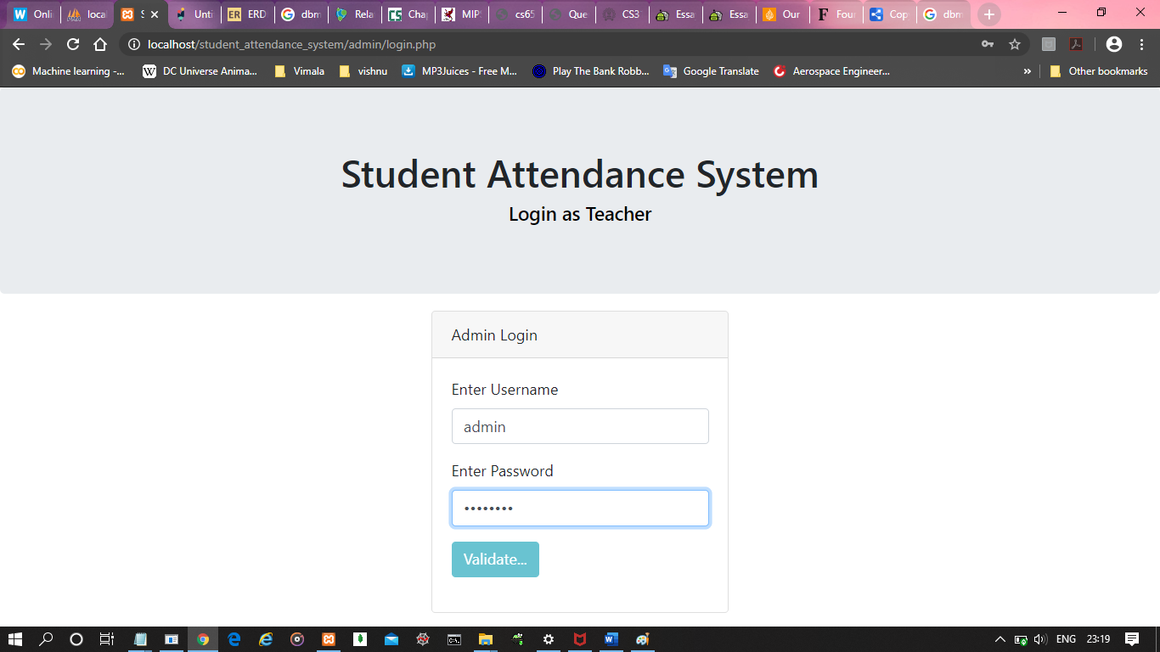

**Attendance status of all the students:**

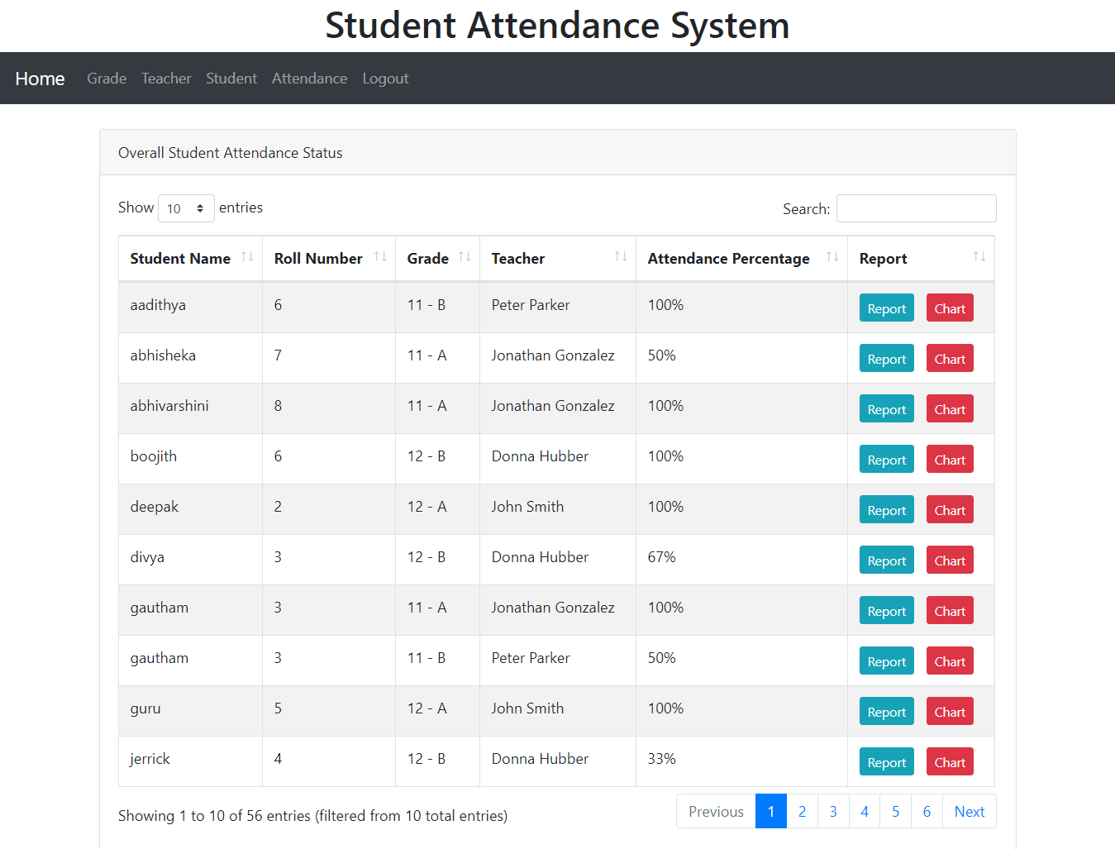

**Grade lists:**

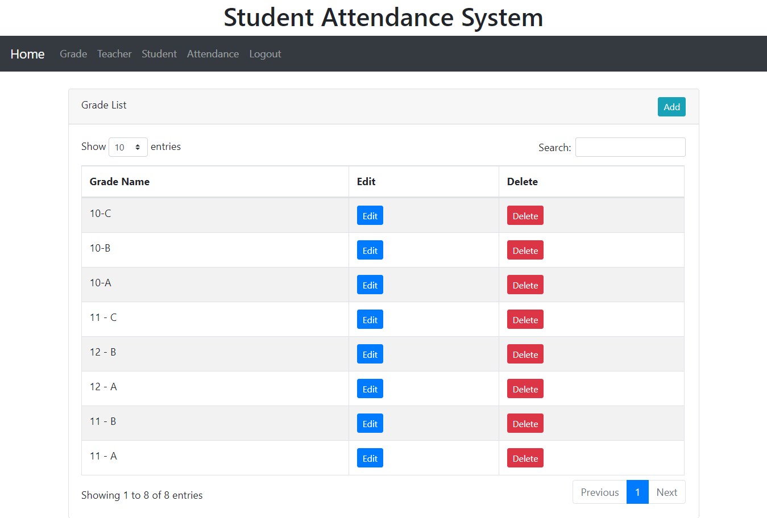

**Add grade:**

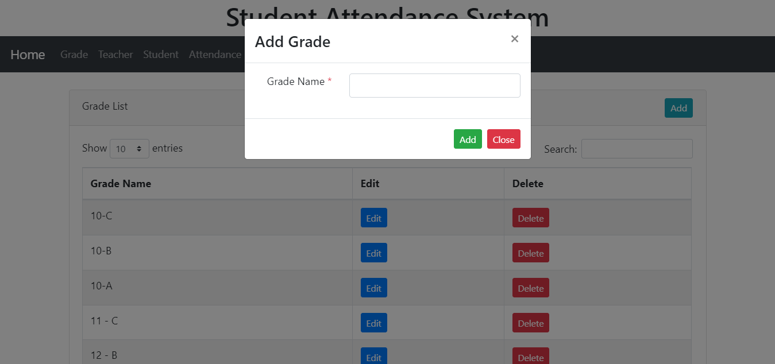

**Edit Grade:**

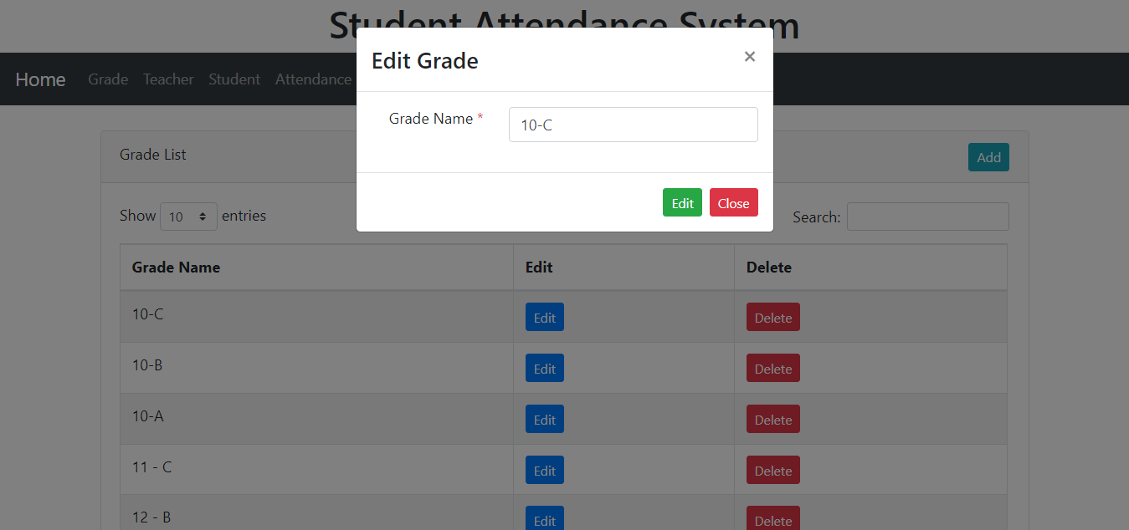

**Delete Grade:**

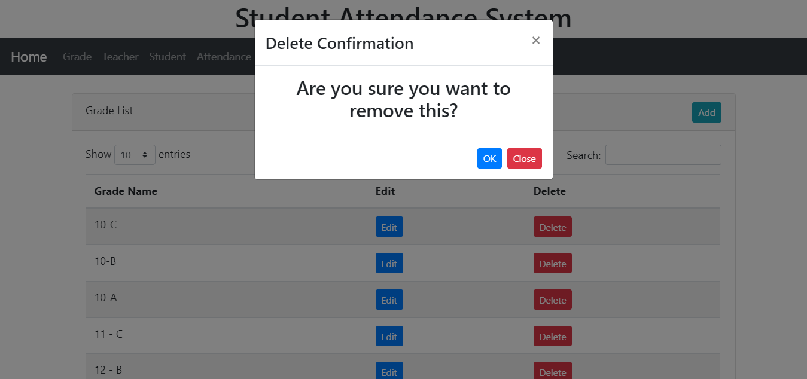

**Teacher List:**

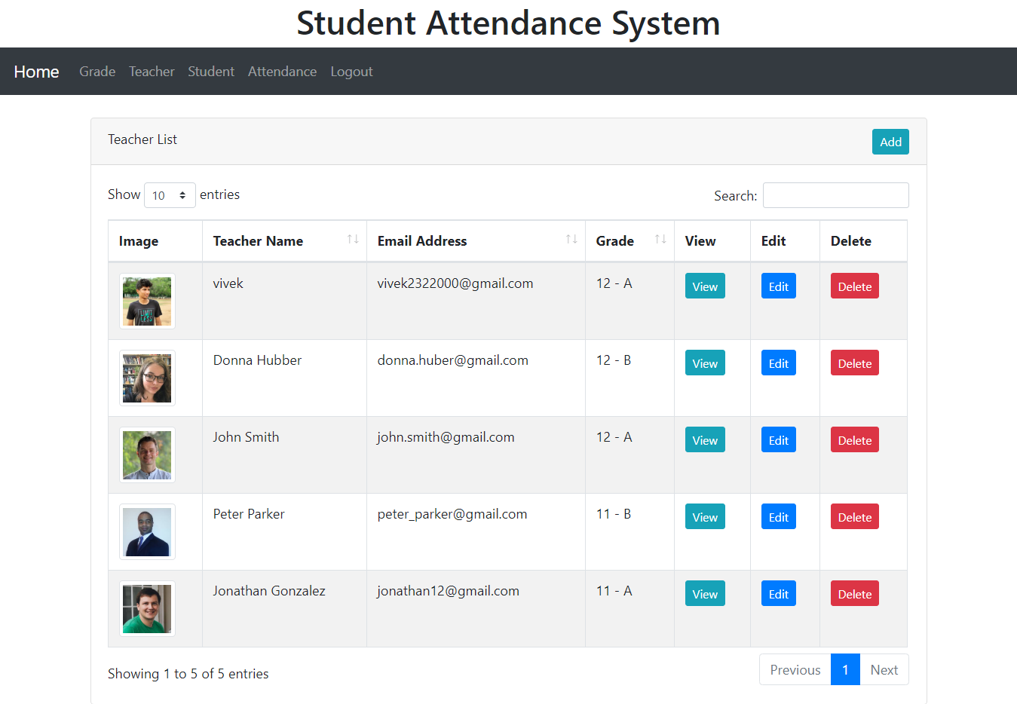

**Teacher Details:**

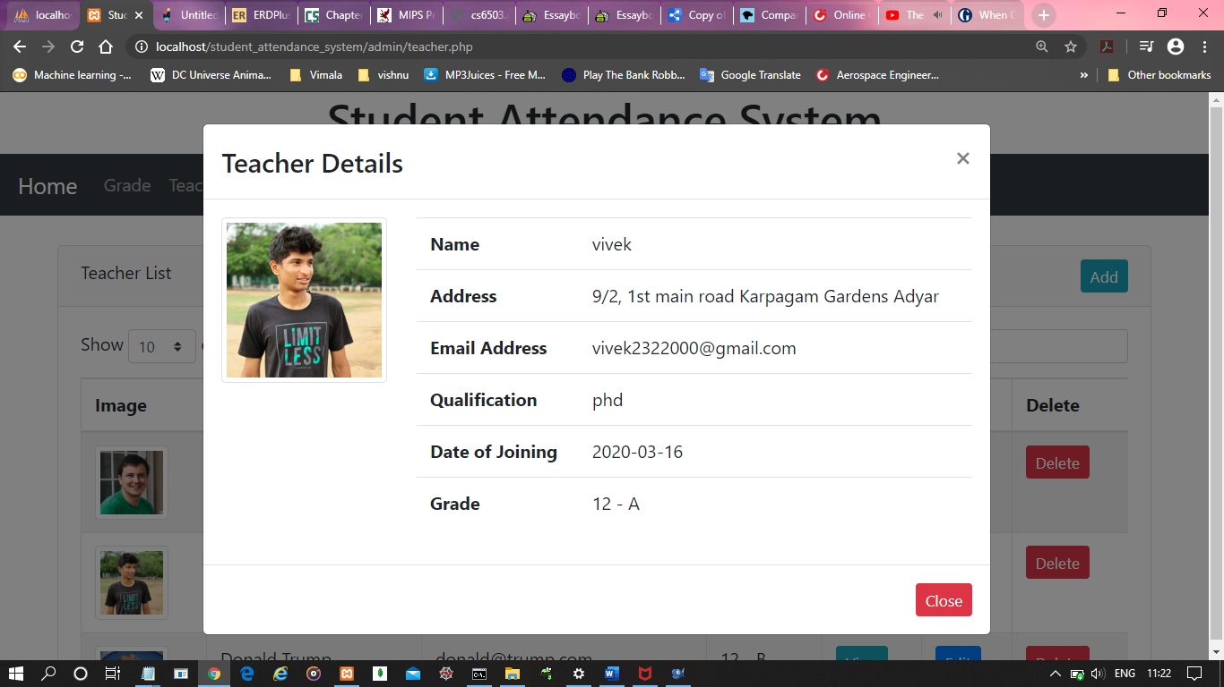

**Add Teacher:**

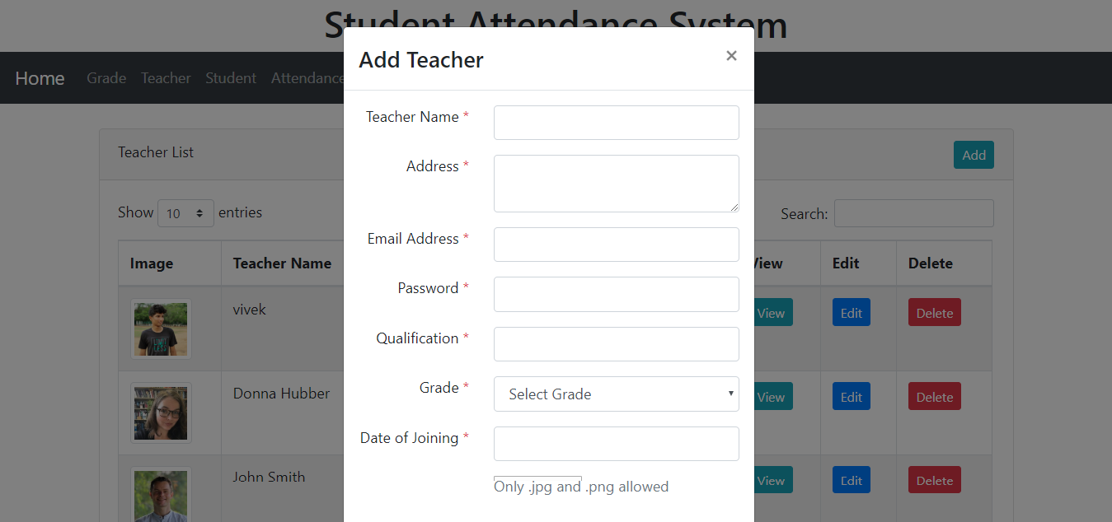

**Student List:**

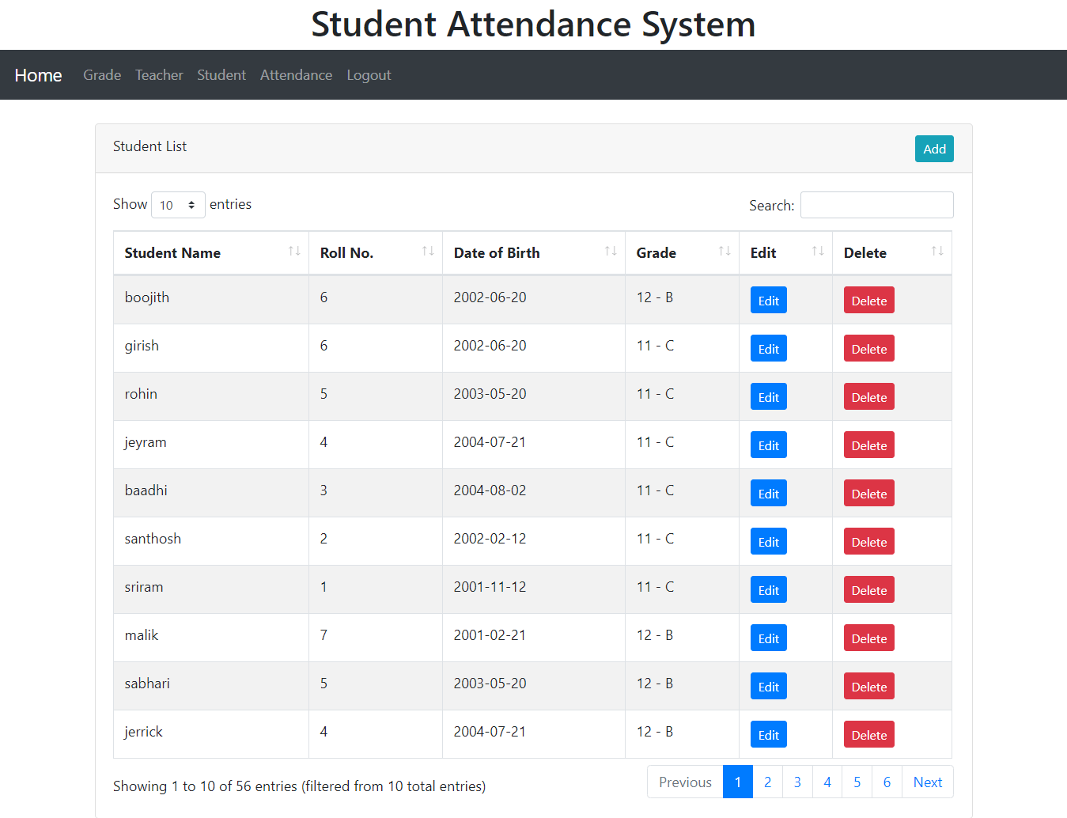

**Edit Student:**

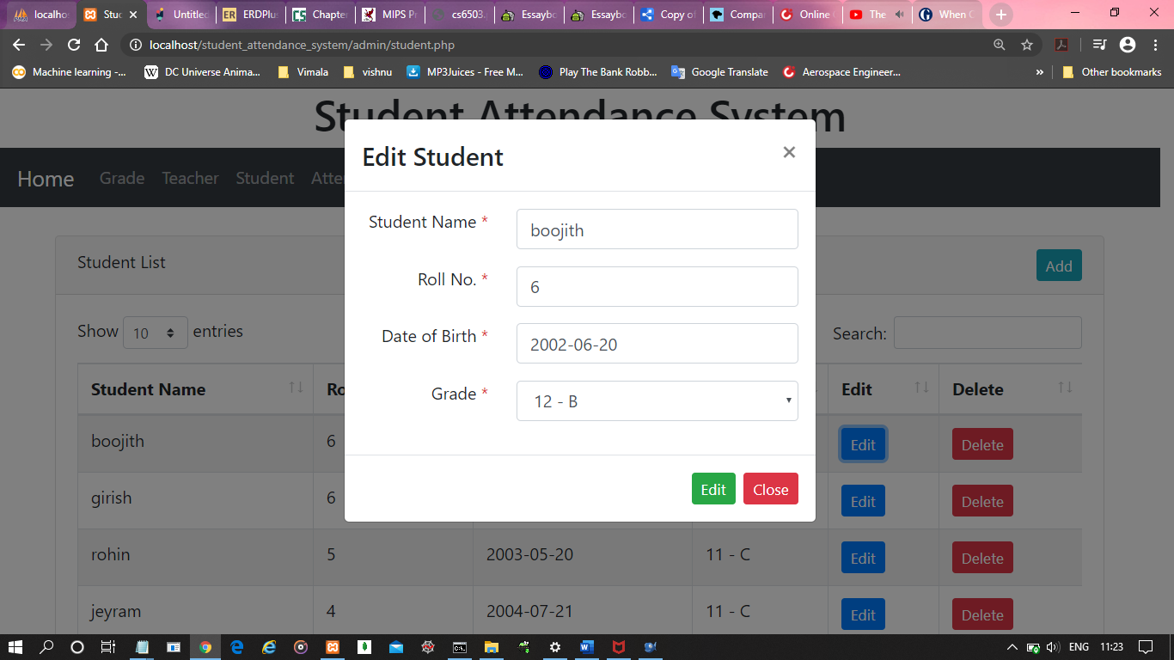

**Add Student:**

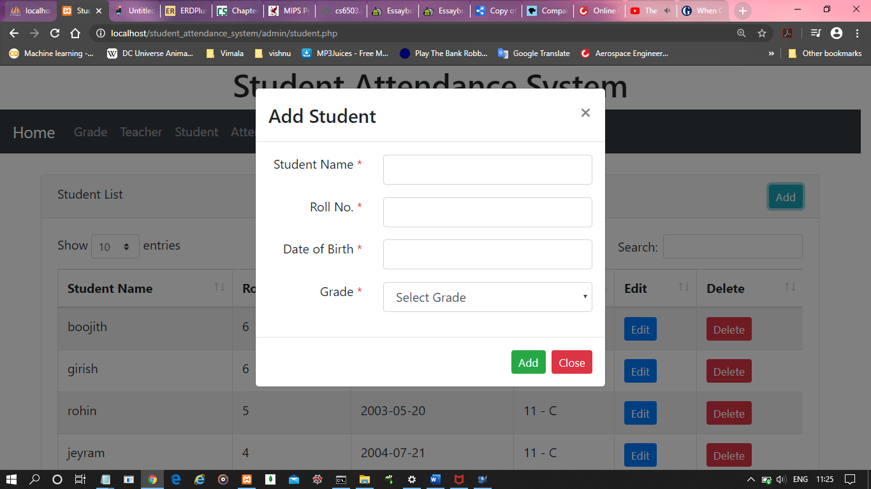

**Search for any student by name, roll no, date of birth, grade:**

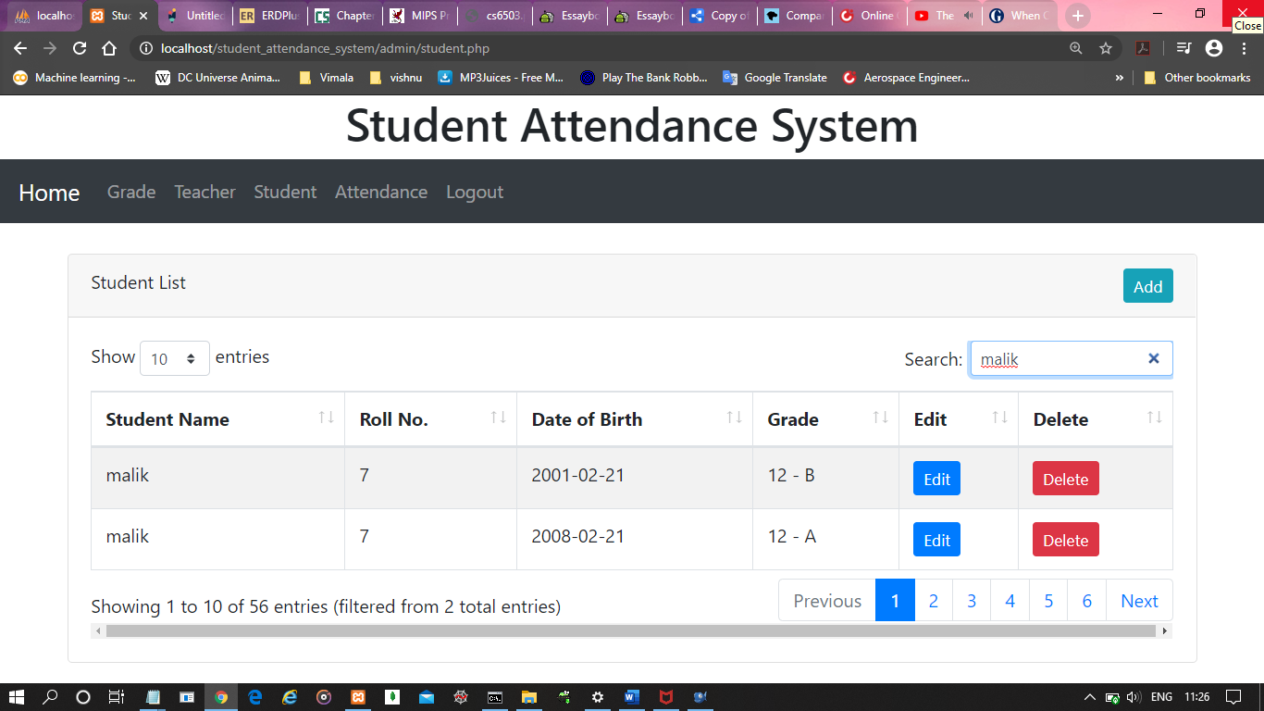

**Attendance List of Students:**

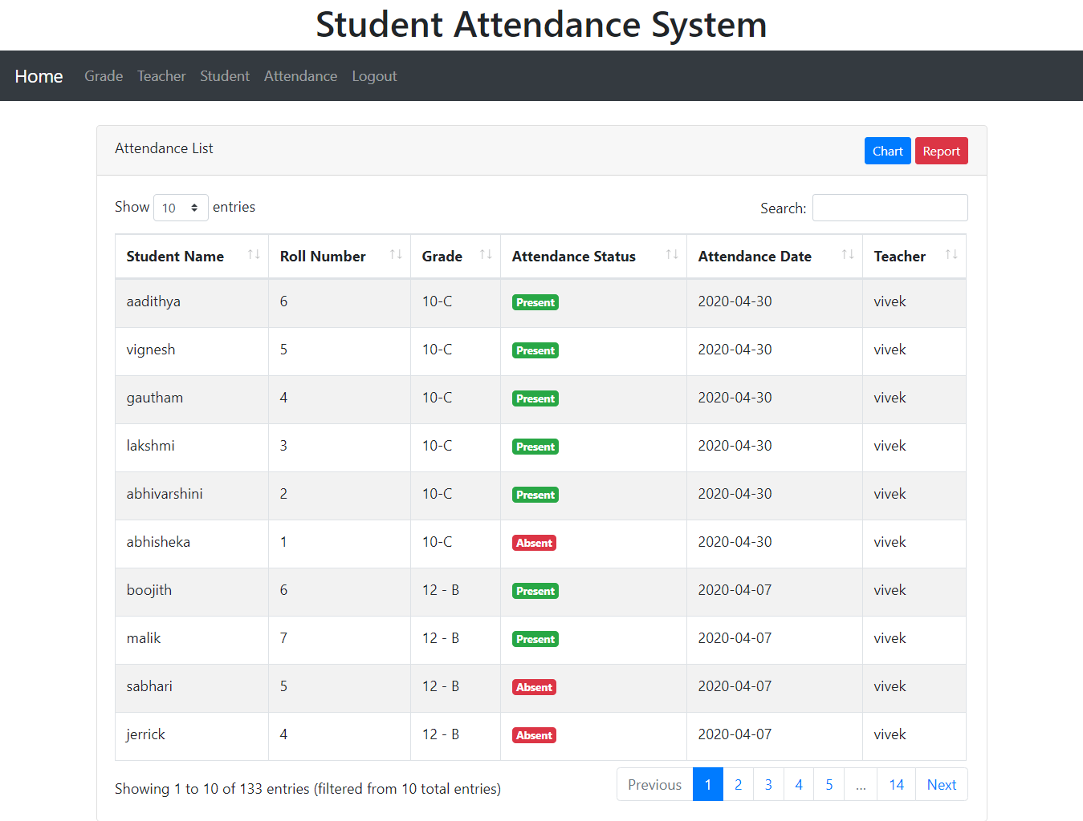

**Create Chart/Report for any particular student between particular intervals:**

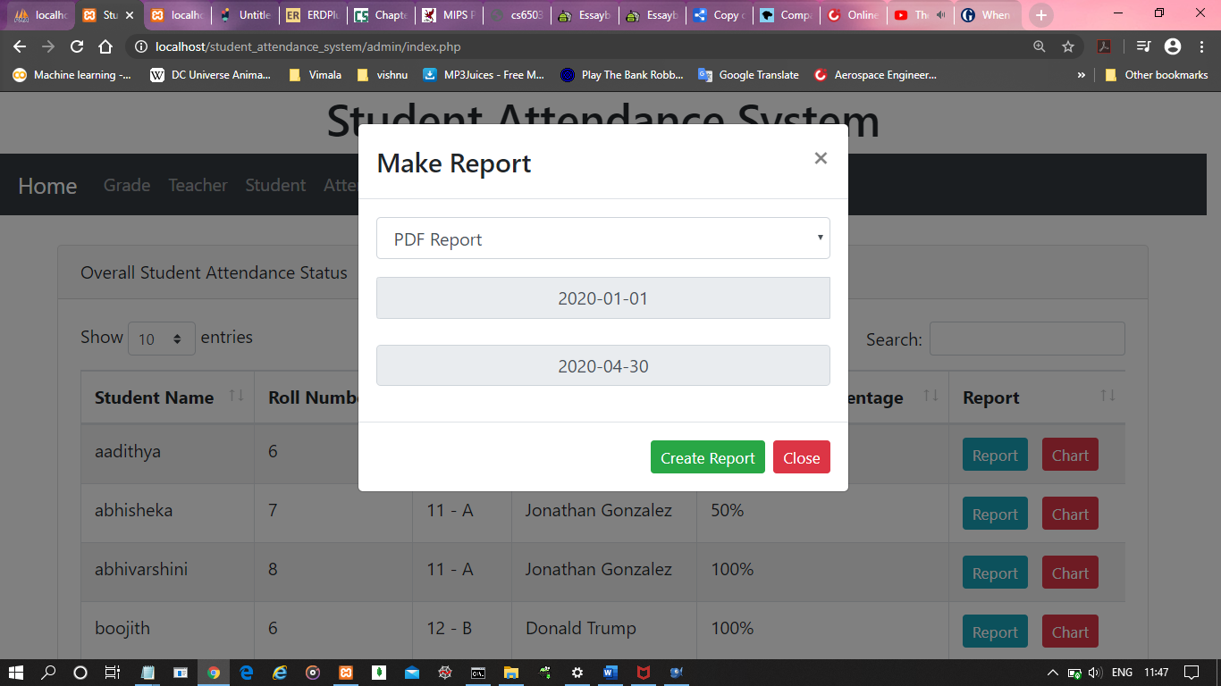

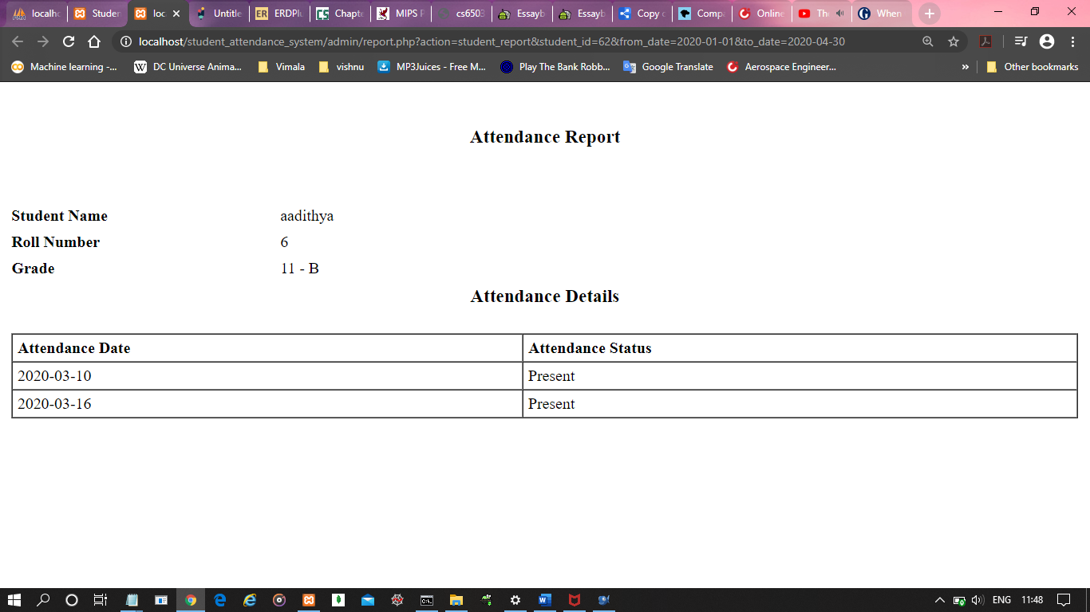

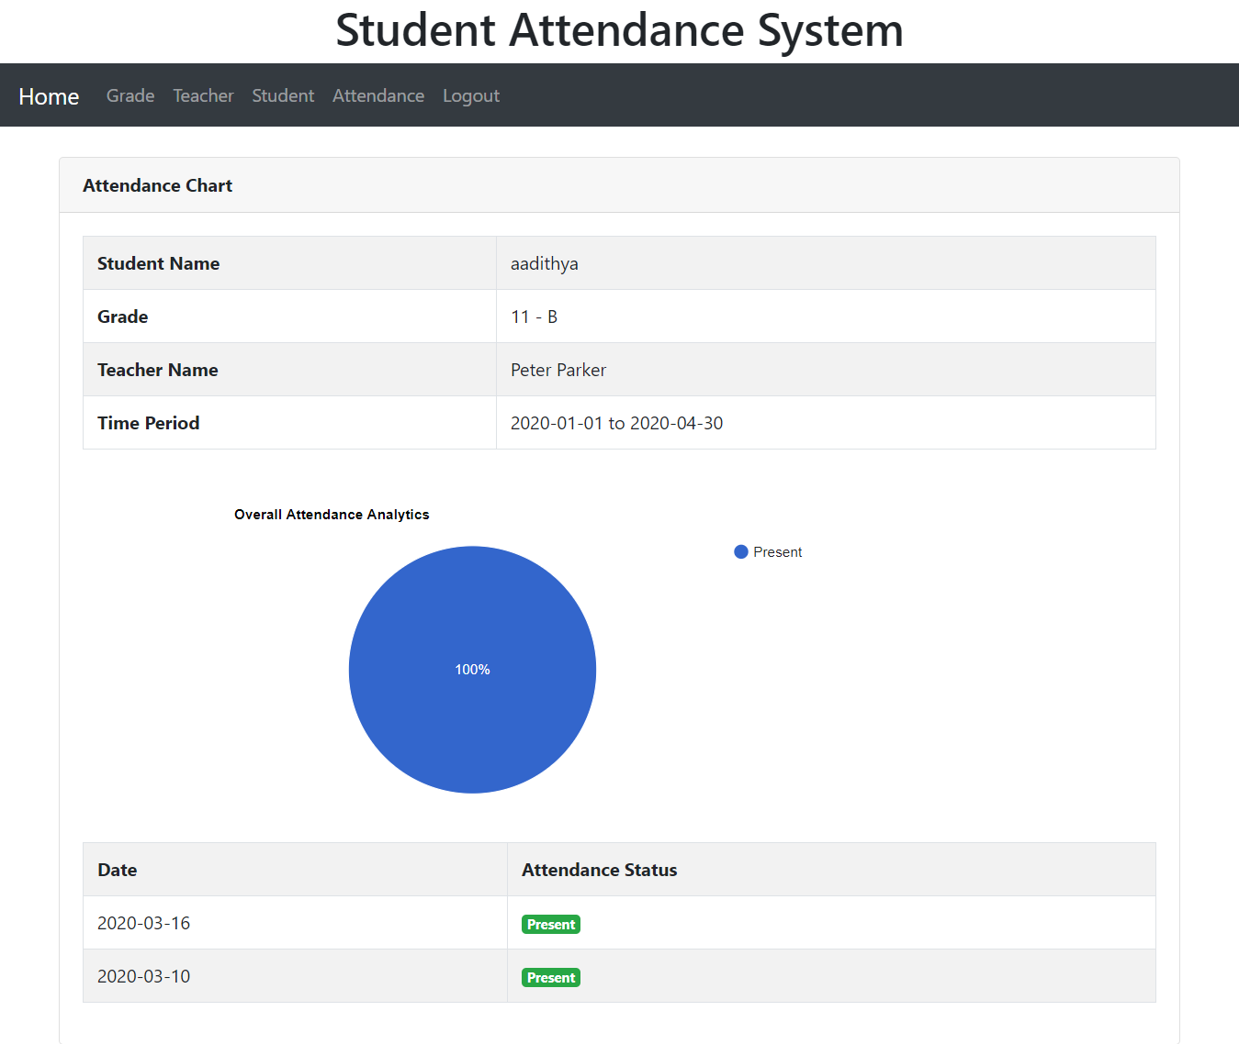

**Create Attendance Chart of an entire Grade for a particular Date:**

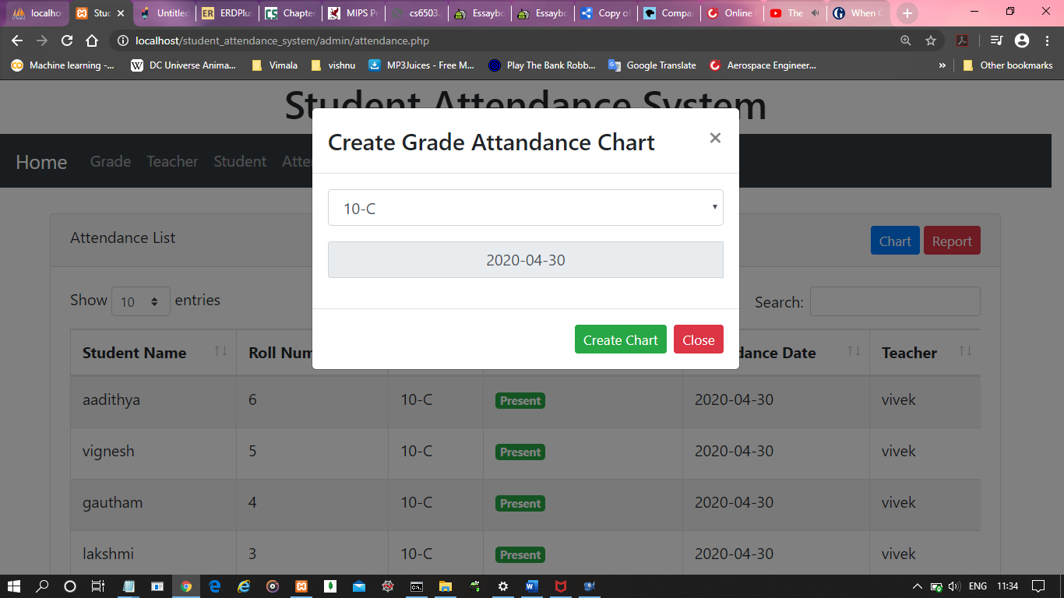

**Create Attendance Chart of an entire Grade for a particular Date:**

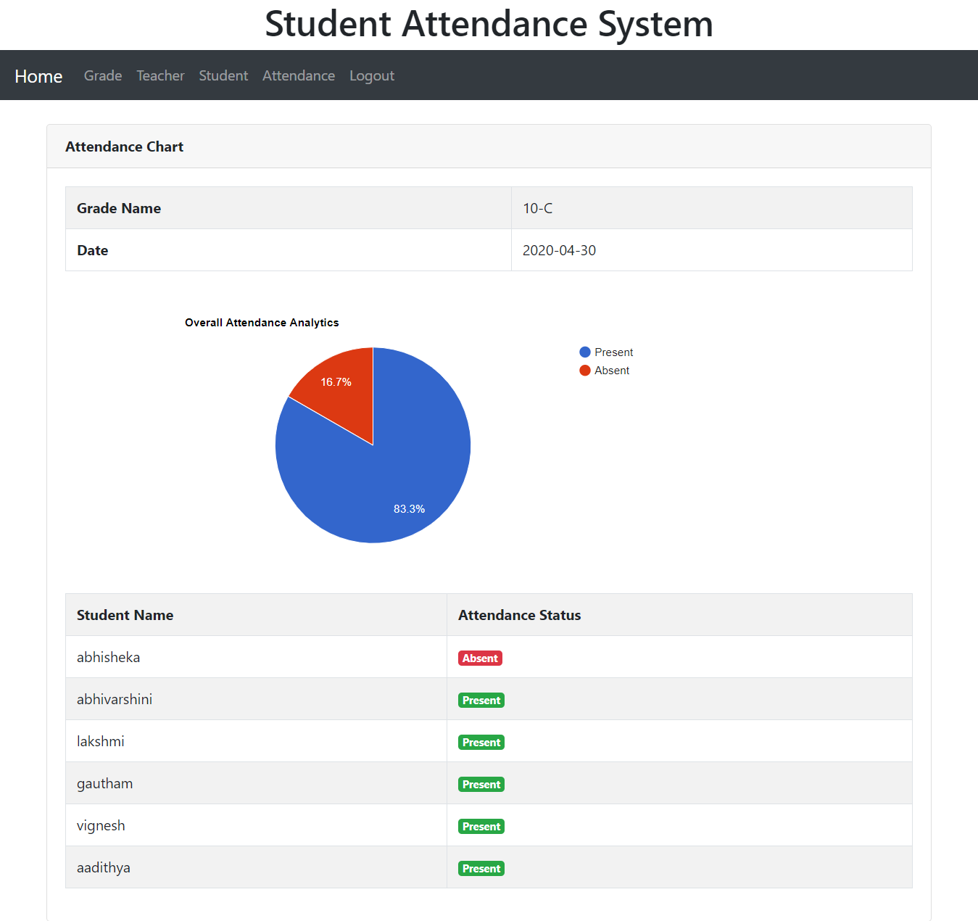

**Make Attendance Report between any intervals for an entire Grade:**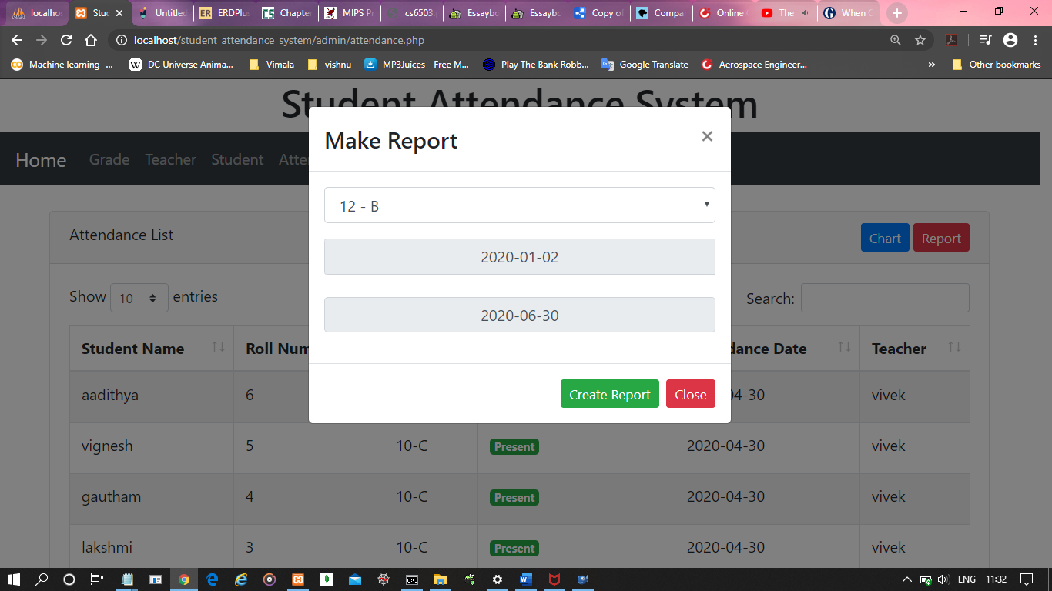

**Make Attendance Report between any intervals for an entire Grade:**

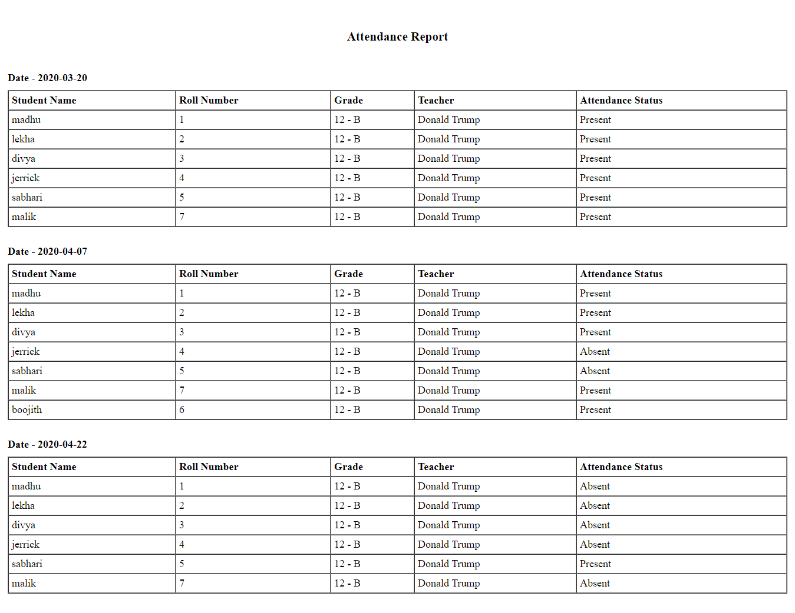

***TEACHER LOGIN:***

**Login Page:**

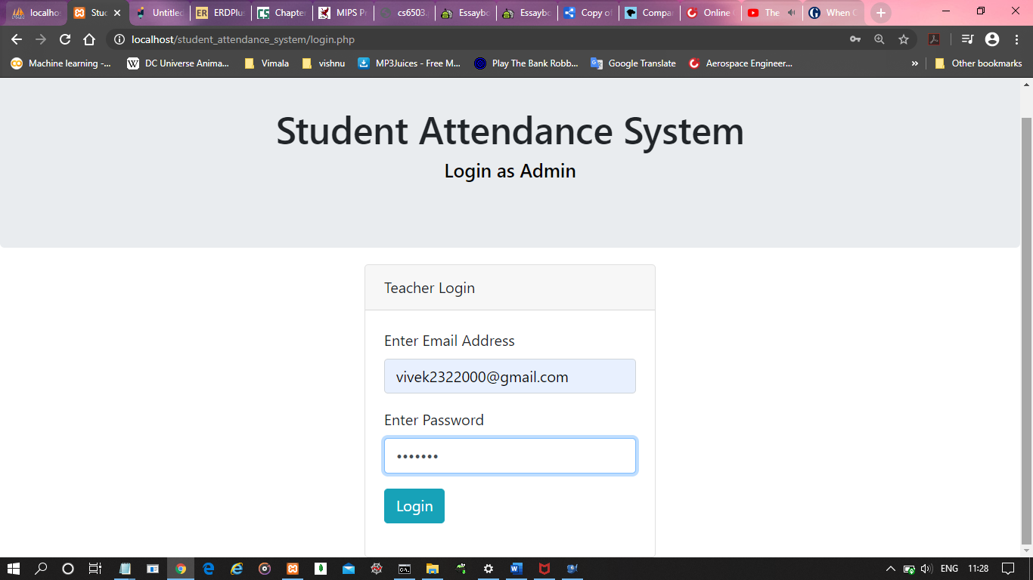

**Overall Student Attendance of Students:**

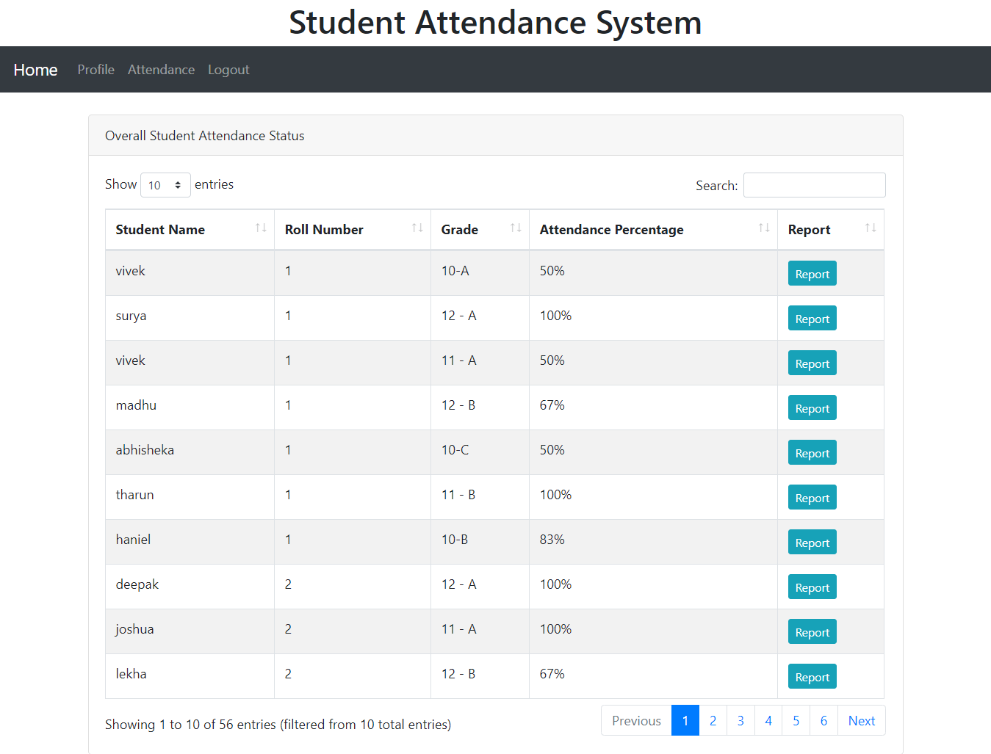

**Search for any student by name, roll no, grade:**

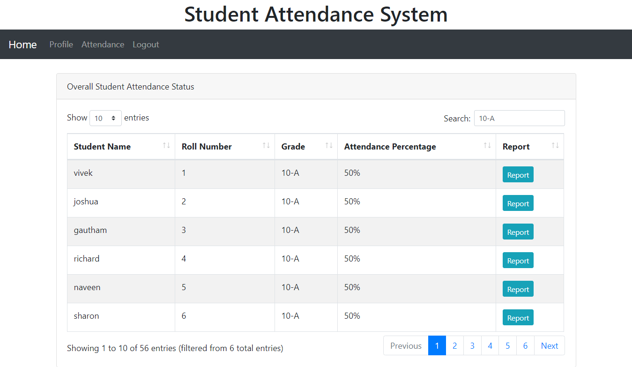

**Edit any Student’s Profile**: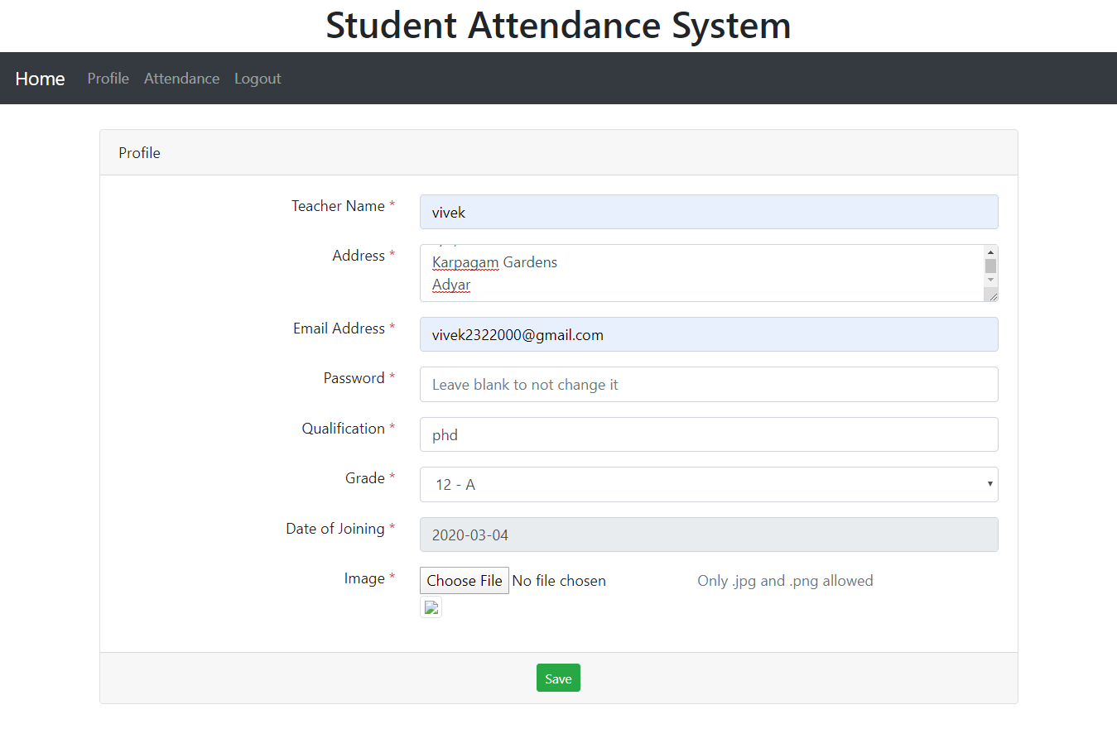

**Attendance List of Students:**

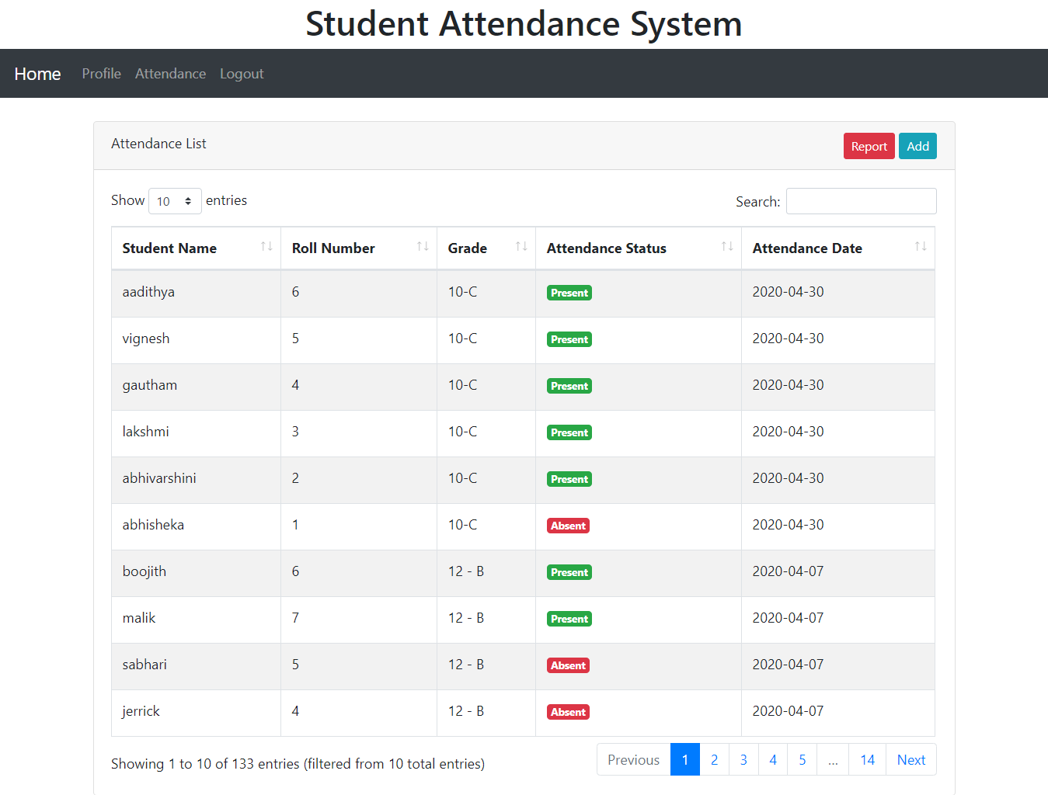

**Add Attendance for any grade:**

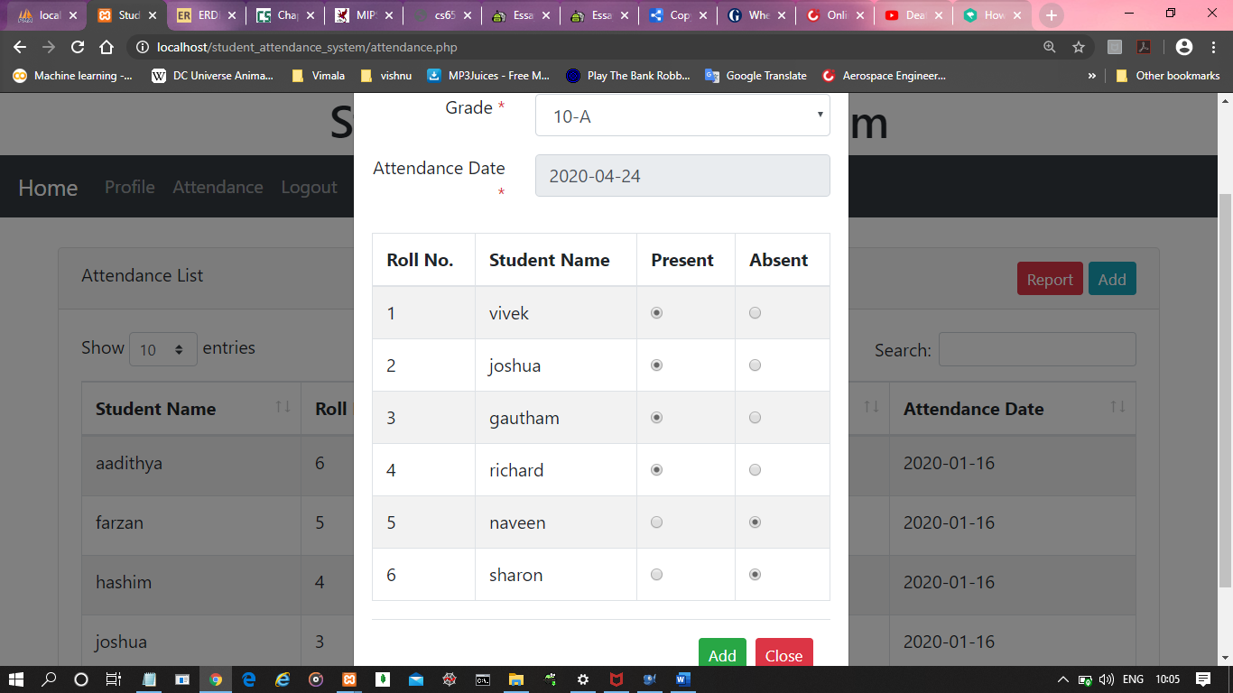

**Make Attendance Report for any particular student between Intervals:**

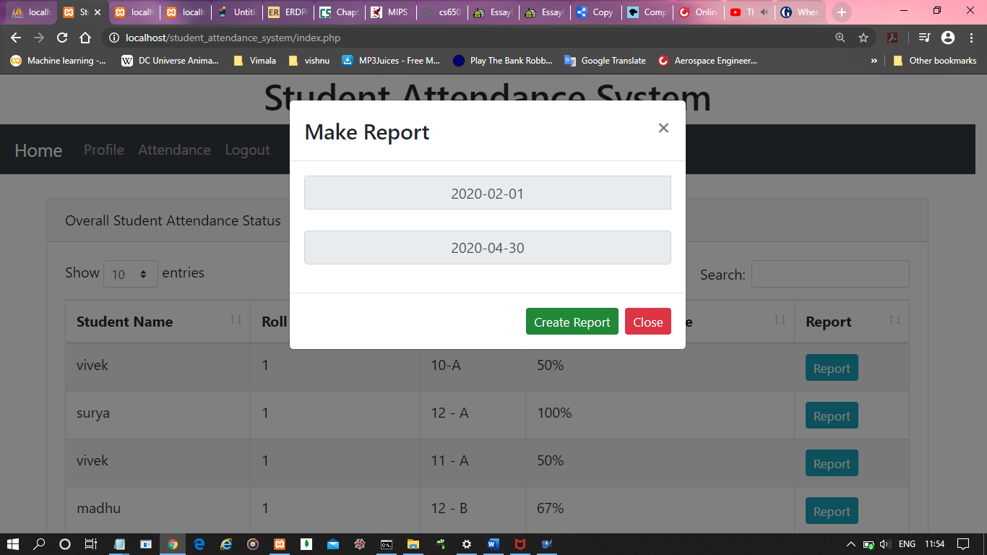

**Attendance Report for any particular student between Intervals:**

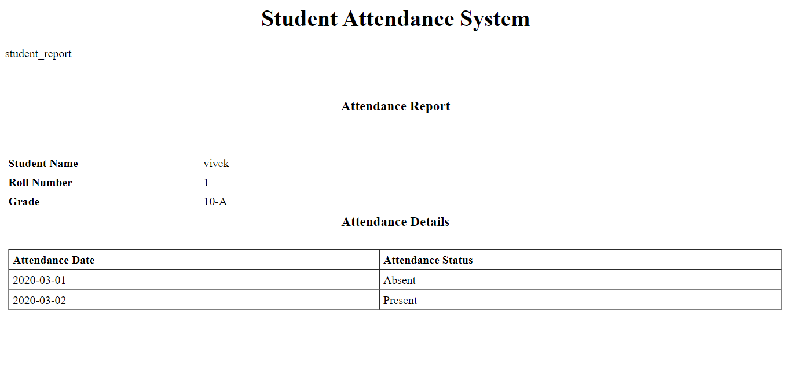

**Make Attendance Report of all Classes between any Interval:**

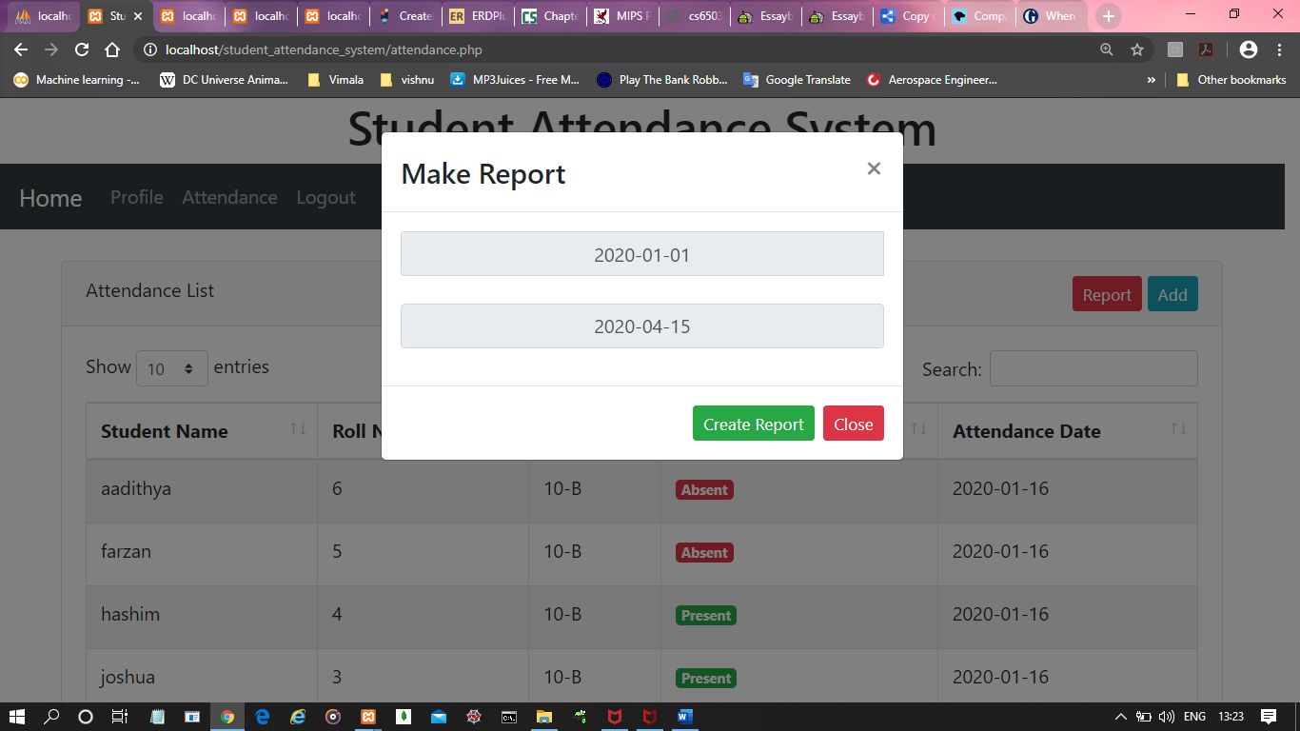

**Attendance Report of all Classes between any Interval:**

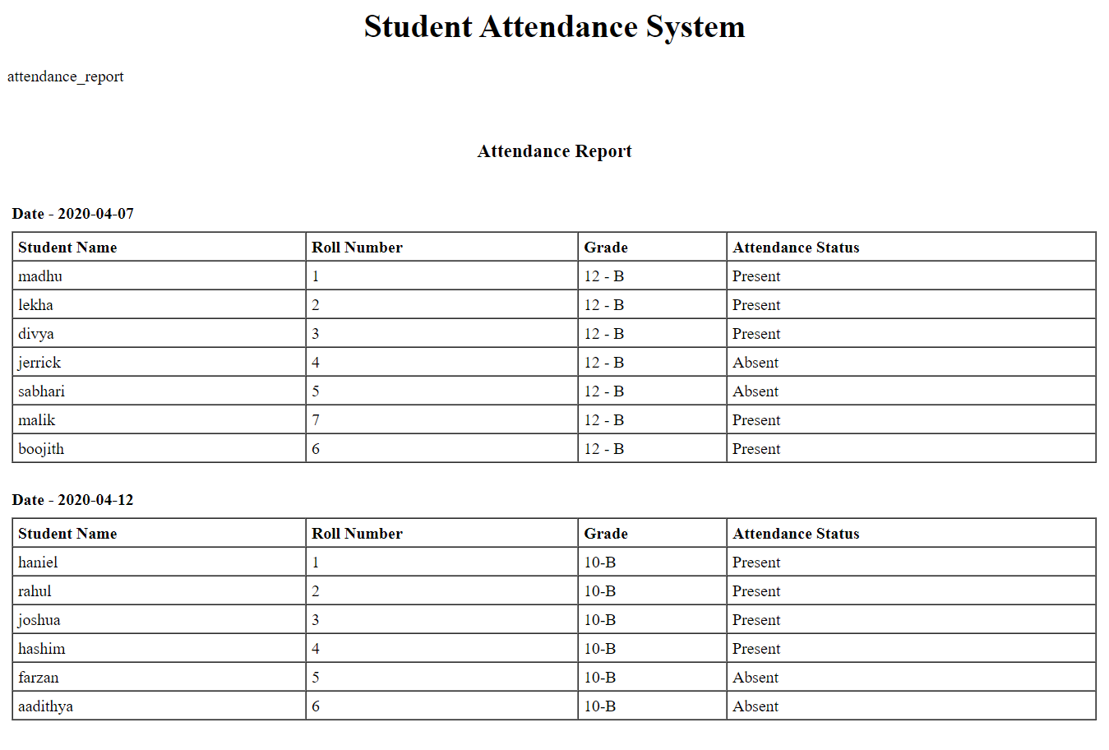

***TRIGGERS USED :***

**Data Inserted into tbl_student_log:**

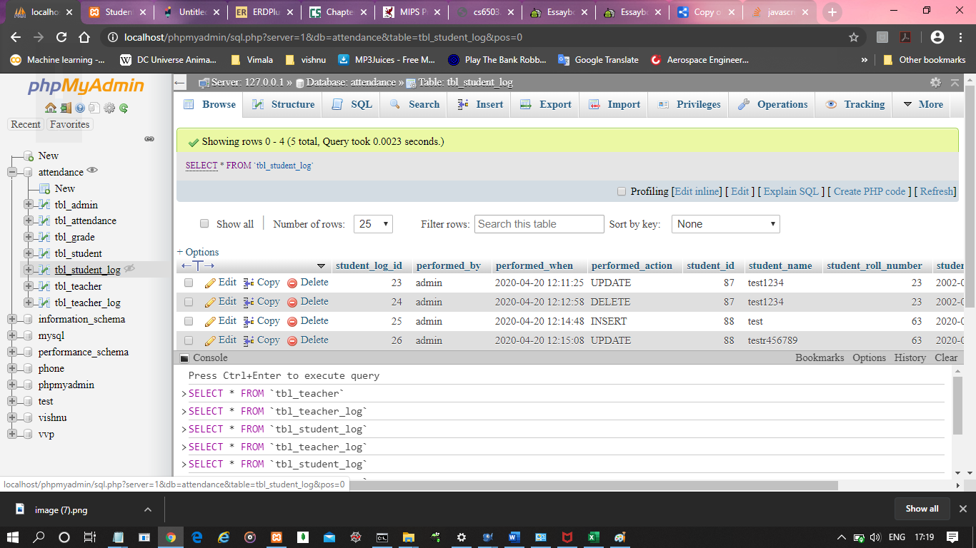

**Data Inserted into tbl_teacher_log:**

